**Add me on the call too**

**Why should you create test logs?**

* If you want to prove what you tested “two” days ago;
* Traceability. You can mark every test case you have tested and be sure that you won’t check it the second time or that you won’t miss something important.
* Senior QAs/Mentors/Leads can verify that the most junior people tested everything needed and didn’t skip any important test cases.

To operate with my test logs, I use a couple of tools: Notepad++, Evernote, [**Test Case Manager**](https://testcasemanager.codeplex.com/), and [**Auto Hotkey**](http://automatetheplanet.com/2014/03/15/useful-hotkey-macros-using-autohotkey/).

**Sample Test Log**

———————————————————————————————————————

20-Sep-2013 09:17:48

———————————————————————————————————————

1. *NEW* /LIVE/ “Browser: Login with Gmail Chrome” (23-Sep-2013 09:44:20)

newUser@gmail.com

Client id = 123

<https://mail.google.com/mail/u/0/#inbox>

Login page displayed => OK

Previous account name displayed => OK

Login => OK

Logout Button available => OK

</OK>

———————————————————————————————————————

2. *45623 * /TEST/ “Browser: Login with Gmail Firefox” (23-Sep-2013 09:50:20)

secondUser@gmail.com

Client id = 222

<https://mail.google.com/mail/u/0/#inbox>

Login page displayed => OK

Previous account name displayed => OK

Login => OK

Logout Button available => FAIL

</FAIL>

———————————————————————————————————————

3. *RETEST* /STAGING/ “Browser: Login with Gmail IE 10” (23-Sep-2013 09:55:20)

thirdUser@gmail.com

Client id = 111

<https://mail.google.com/mail/u/0/#inbox>

Login page displayed => OK

Previous account name displayed => OK

Login => OK

Logout Button available => OK

</OK>

**The Format**

First you use the “time” + “—”   snippets (Auto Hotkey) or just type them manually.

You can specify a special tag or test case id in the following format: **\*NEW*, *RETEST*, *1234587\***

**/STAGING/** – the environment that you use for testing

“Browser: Login with Gmail IE 10” – the test case name

**(23-Sep-2013 11:28:25)** – the start time of the test execution

After these attributes, you can put data related to the current test case like client ids, order detail ids, URLs, emails, anything that helps you to recover what you have done.

You can also add what you have covered:

* Login page displayed => OK
* Previous account name displayed => OK

**“=> OK”** – test validation passed

**“=> FAILED”** – test validation is not ok

At the end of the test case log write the final execution status of the test case:

**“</OK>”** – test case passed

**“</FAILED>”** – test case failed

Use the following format if the test cases are related:

*Test Case 1:*  
1. Login with user “A”  
2. Add purchase  
*Test Case 2:*  
1. Login with user “A”  
2. Renew the previous purchase

Note that the “—-” separator is skipped.  
If the test cases are not related, you can separate them with it.

At the end of each day, you store your current test log in Evernote with Tag: “Test Logs”,  Note Name = “Current Date”. You can also encrypt it if there is a sensitive information.

Later you can use the powerful search of Evernote if you want to find something in your old test logs.

Test Logs Evernote

[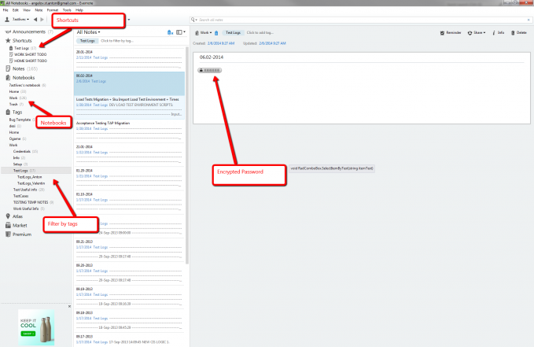](http://automatetheplanet.com/wp-content/uploads/2014/03/evernote_desktop_app.png)

Test Logs Notepad++

[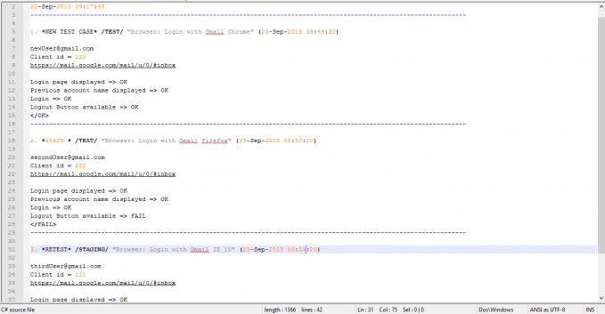](http://automatetheplanet.com/wp-content/uploads/2014/03/test_logs_notepad.png)